Rimon Sawa

**CPE301 – SPRING 2018**

Design Assignment 1

**DO NOT REMOVE THIS PAGE DURING SUBMISSION:**

The student understands that all required components should be submitted in complete for grading of this assignment.

|  |  |  |  |
| --- | --- | --- | --- |
| **NO** | **SUBMISSION ITEM** | **COMPLETED (Y/N)** | **MARKS**  **(/MAX)** |
| 1 | COMPONENTS LIST AND CONNECTION BLOCK DIAGRAM w/ PINS |  |  |
| 2. | INITIAL CODE OF TASK 1/A |  |  |
| 3. | INCREMENTAL / DIFFERENTIAL CODE OF TASK 2/B |  |  |
| 3. | INCREMENTAL / DIFFERENTIAL CODE OF TASK 3/C |  |  |
| 3. | INCREMENTAL / DIFFERENTIAL CODE OF TASK 4/D |  |  |
| 3. | INCREMENTAL / DIFFERENTIAL CODE OF TASK 5/E |  |  |
| 4. | SCHEMATICS |  |  |
| 5. | SCREENSHOTS OF EACH TASK OUTPUT |  |  |
| 5. | SCREENSHOT OF EACH DEMO |  |  |
| 6. | VIDEO LINKS OF EACH DEMO |  |  |
| 7. | GOOGLECODE LINK OF THE DA |  |  |
|  |  |  |  |
|  |  |  |  |

* **COMPONENTS LIST AND CONNECTION BLOCK DIAGRAM w/ PINS**

Components used: ATmega328p and Atmel Studio. No pins were used for this assignment.

* **INITIAL/DEVELOPED CODE OF TASK 1/A**

2. 300 addresses

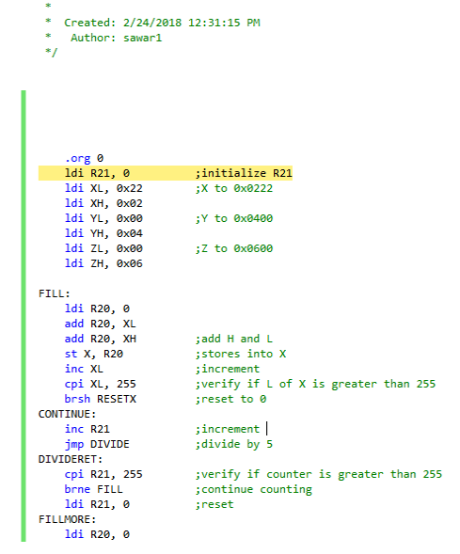

3. Verify if the value is divisible by 5

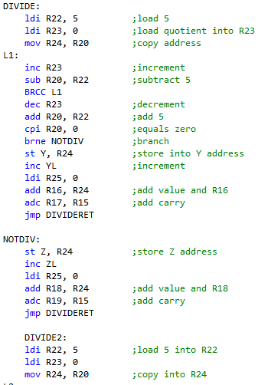

4. values in R16:R17 also R18:R19

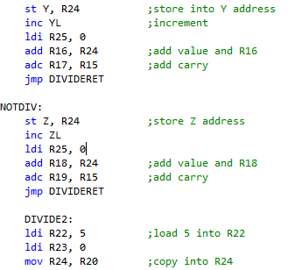

* **MODIFIED CODE OF TASK 2/A from TASK 1/A**

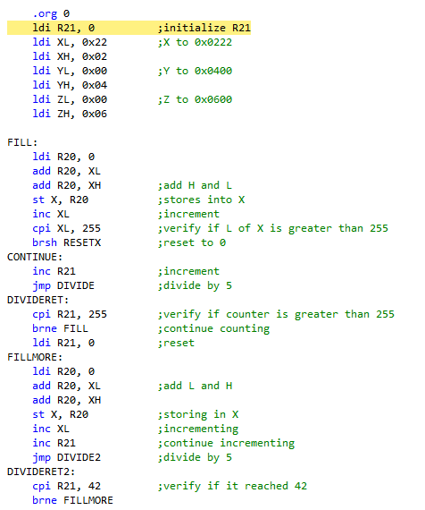

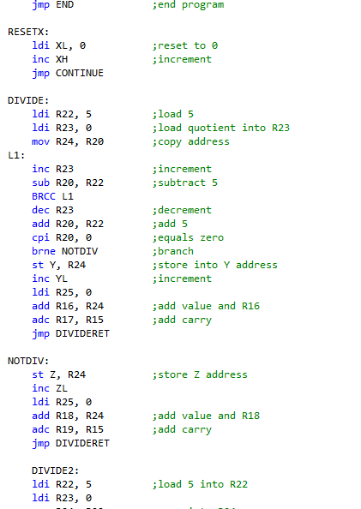

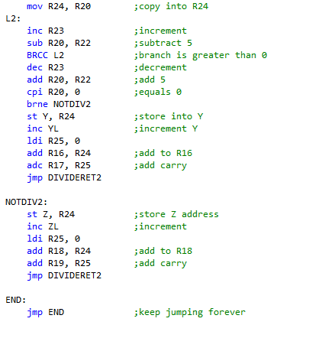

* **SCHEMATICS**
* **SCREENSHOTS OF EACH TASK OUTPUT (ATMEL STUDIO OUTPUT)**

Outputs 0x0222

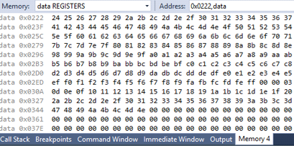

Outputs 0x0400

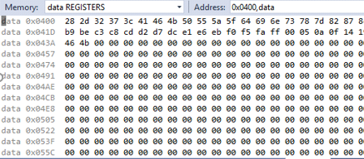

Outputs 0x0600

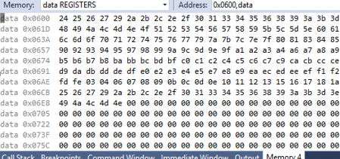

* **SCREENSHOT OF EACH DEMO (BOARD SETUP)**

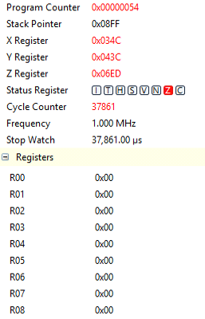

* **VIDEO LINKS OF EACH DEMO**
* **GITHUB LINK OF THIS DA**

https://github.com/rsawa91